Wailea & Makena Magazine
Keiki Corner: March 2023
Written By:
Reading Specialist & long-time Teacher, Mrs. Michelle Lazuka M.Ed
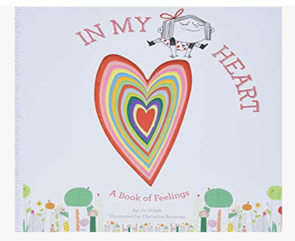

KEIKI BOOK FAVORITES!

AGE: 1-4
Here We Are
In My Heart
AGE 5-10
The Bookshop Cat
Have You Filled a Bucket Today?
Farfalina and Marcel
Animal Bff’s
Punky Aloha
The Snail and the Whale
AGE 6-12
I Survived chapter books
The Owl Diaries
Who Would Win? series

Keiki LOVE all these, which were chosen to promote and encourage children to want to read. We want our little ones to be happy and engaged while reading and learning! These books check all those boxes. And, as a bonus, they teach valuable lessons on kindness, care for our environment, care for others, and end with a heart-warming message.

I can’t wait for you to enjoy these favorites as much as my students and I do. Happy Reading!

